INSTALL THE ENGAGEVR VIRTUAL REALTY APPLICATION
In order to attend events (or meetings) in ENGAGEVR you will need to complete the following:
- Create a free ENGAGEVR account (i.e., Username, E-mail, and Password) from the ENGAGEVR website (https://engagevr.io).
- Install the ENGAGEVR application on your Quest 2.
- Install ENGAGEVR on your PC or Mac computer as a backup. If you are not able to attend your class using your Quest 2, you could, alternatively, access the class using the computer version.
- Install the ENGAGEVR app on your cell phone or tablet device (optional). While this step is optional, you may find accessing ENGAGEVR from a mobile device as a backup as well. Note that the level of functionality across devices diminishes substantially as you move from Quest 2 to computer to mobile device.
Download ENGAGEVR to PC, Mac, and Mobile Devices
Download the ENGAGEVR desktop, tablet, and cell phone applications here: https://engagevr.io/download/.
ENGAGEVR Download and Support FAQ
The ENGAGEVR FAQ covers a great deal of helpful information, including installation, computer and Internet speed requirements, and hosting public and private meetings.
https://engagevr.io/download-support/faq/
HOW TO ATTEND A MEETING IN ENGAGEVR
To attend a meeting or event in ENGAGEVR, follow the steps below:
Step 1: Turn on your Quest 2 virtual reality headset and place it on your head, securely. Adjust the head strap, if necessary, to create a comfortable fit.
Step 2: Navigate to your applications library, locate the ENGAGEVR application, and launch (start) it by clicking on the ENGAGEVR icon.
Step 3: Once the application loads, you will be prompted to login using the username or e-mail address and password you first created your account.
Figure 1: The ENGAGEVR Login Screen
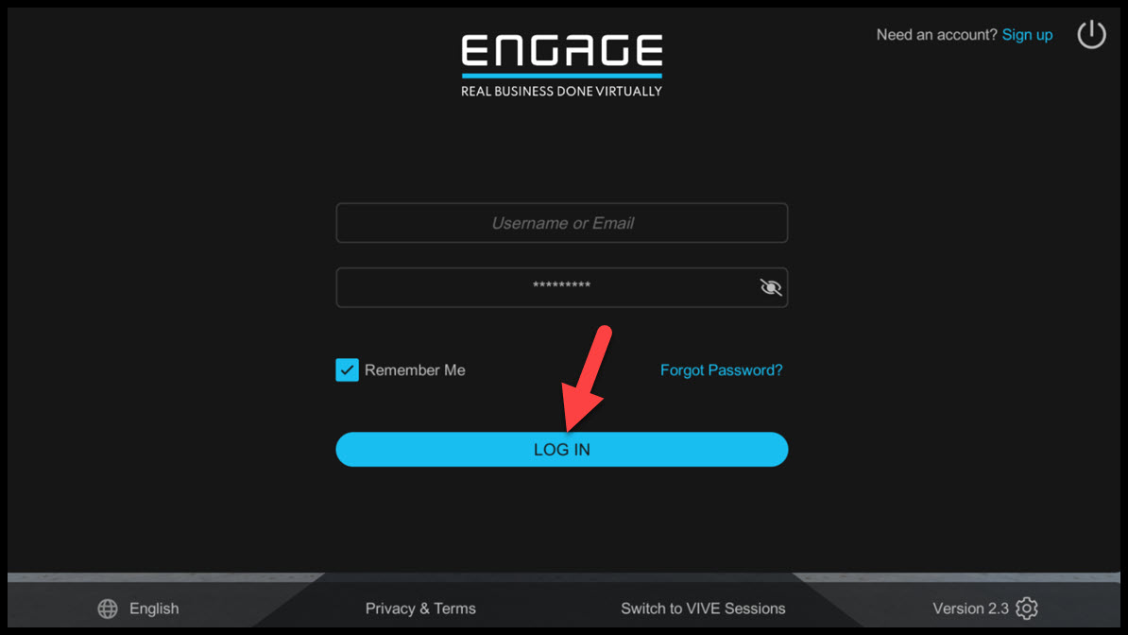
Step 4: Click the blue LOG IN button (seen in Figure 1) to run the ENGAGEVR application.
Figure 2: The ENGAGEVR Main Menu
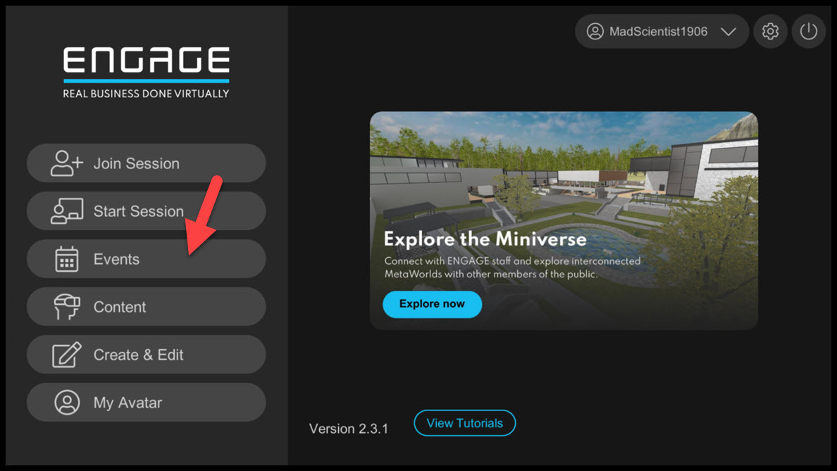
Step 5: Select Events from the main menu, then the Public Tab, to view the list of scheduled events.
Figure 3: Event List
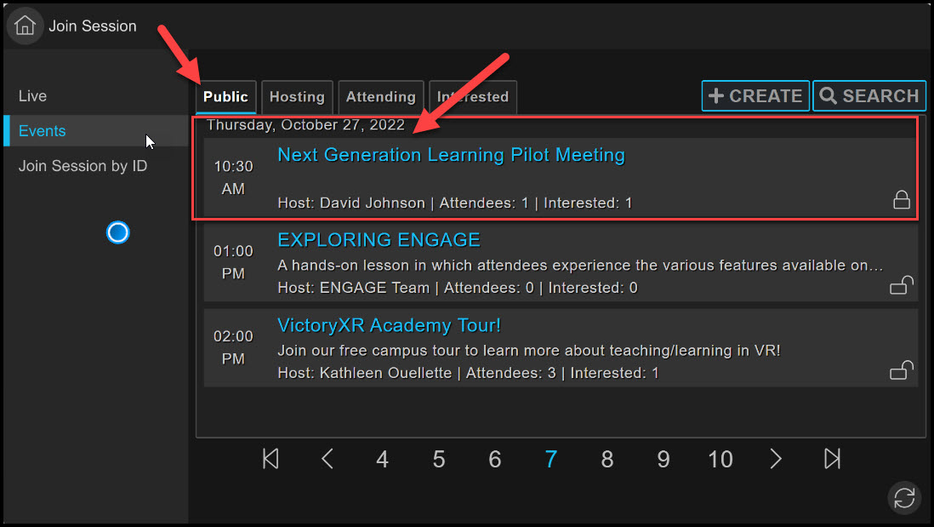

Step 6: Locate the event you would like to attend from the list provided and select it. You may have to scroll through several pages to locate yours.
Figure 4: Event Screen
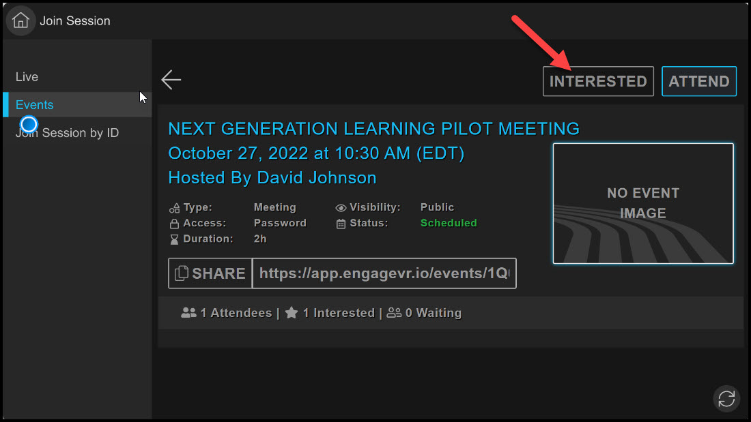
Step 7: Once you located the event, click the Interested button to RSVP in advance—the button text will change to You Are Interested to indicate your RSVP was registered. If the event has not started, return shortly before the start time. When the event host is ready to receive attendees, the button will change to Join. Click Join to enter the meeting. ENGAGEVR will open at the location the meeting organizer has designated.
At some point in this process, you will be prompted to add the Event password, which is: 123VR.

Figure 5: The UMGC Classroom Learning Space
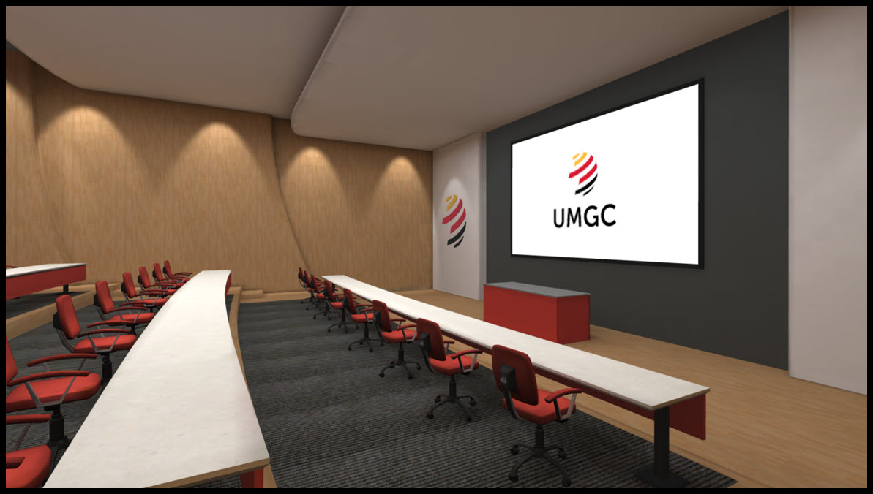
RSPV to an Event via the ENGAGEVR.IO website.
Note: You can also RSVP to an Event via the ENGAGEVR.IO website. If you are sent an Event Link, please click on it and it will take you to the ENGAGEVR.IO website. You will be prompted to sign-in to your account. Once you do, you will be able to RSVP online. After you do so, simply follow the steps below to enter ENAGEVR from your Oculus Quest 2, locate the event, and join once the host has opened the event.
USING ENGAGEVR FROM A COMPUTER (PC OR MAC)
If you are unable to use your Quest 2 to attend your class for any reason, a computer, phone, or tablet device can be used as a backup method. While the computer experience in VR is not as robust in functionality as using the Quest 2, it can be used as a viable alternative to attend your VR class sessions and interact with your Instructor and classmates.
Panning
Use your Mouse to pan (look) around left, right, up (towards the sky), and down (towards the ground).
Navigation
Position your Mouse in the direction you want to move, then use the left, right, up (forward), and down (backward) arrow keys or W (forward), S (backward), A (left), and D (right) keys on your computer keyboard to move in the space.
Teleport
To teleport to a different location with a space, click-hold-and-drag your Right Mouse Button. You will see a circle. Use your Mouse to move the circle to an area you want to teleport to. If the circle is red, it means you can not teleport to that location. If the circle is green, it means you can teleport to that location. Position the green circle to the desired teleport location, then release the Right Mouse Button and your avatar will be teleport to that location.
Sitting Down
In order to sit on a chair, sofa, or other object which allows sitting, use the teleport controls above to navigate your circle over an object you would like to sit on (a chair for example). A “Sit” icon will appear, indicating that you can sit on the object. Release the Right Mouse Button and your avatar will sit down in the desired seat. To stand up, simply move your avatar forward, backward, left, or right.
Using the Tablet
The Tablet in ENGAGEVR is used to utilize the majority of the features available in ENGAGEVR (e.g. raise hand, take a selfie, exit a session or event, load a presentation or video, and mute your mic). In order to use the Tablet, click the Escape (ESC) key. This will make the Tablet appear. Clicking the Escape key while the Tablet is visible will cause the Tablet to disappear.
Creating Sticky Notes
In order to create a Sticky Note, follow the steps below:
Step 1: Select the Notes icon on the Tablet.
Step 2: Select the Create button.
Step 3: Enter the title of the Sticky Note.
Step 4: Type the content of the Sticky Note in the Content box.
Step 5: Click the View button to preview the Sticky Note (optional).
Step 6: Click Save Note to save the Sticky Note.
Step 7: Click the Sticky Note button, then select a color from the Select Color drop down menu.
Step 8: Select Create Sticky Note to place the Stick Note in the space.
Moving a Sticky Note
Once your Sticky Note has been placed in the space, it will be automatically selected. While your Sticky Note is selected, pan your Mouse to select a direction to move and use your Arrow Keys or ASWD keys, on your computer, to navigate and move the Sticky Note to the location you would like to stick it to.
Deleting a Sticky Note
In order to delete a Sticky Note, hover your mouse pointer over top of the Note. A Trashcan-shaped Icon should appear to the top right of the Sticky Note (see red icon in Figure 6 below) and a Lock Icon at the bottom (see green arrow in Figure 6 below). Click on the Trashcan Icon to delete the Sticky Note or the Lock button to lock the Sticky Note in place.

Figure 6: Sticky Note
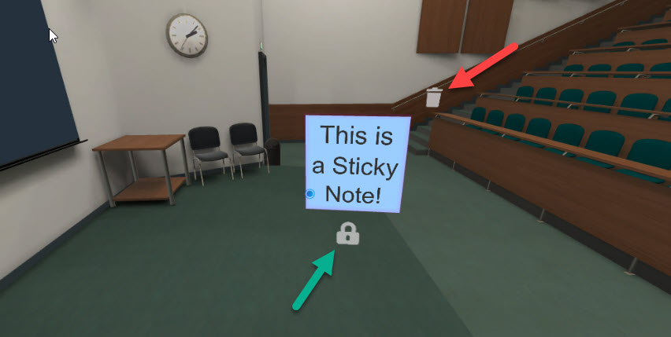
For video instructions on using a computer in EGAGEVR, please view the YouTube video below:
Using a Computer in ENGAGEVR
Topics include:
- Navigating using the Arrow or Computer Keyboard
- Teleporting
- Sitting
- Tablet Features
- Using 3D IFX Objects
- Using the Gizmo
- Creating Sticky Notes
https://youtu.be/-PRx-dIrXzg (18:19 mins | Automatic Closed Captioning)
In Closing
We hope that you found this brief tutorial helpful.

